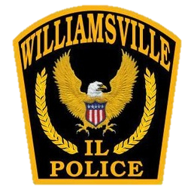
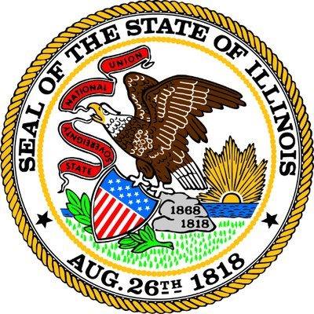
Police Department
Williamsville, Illinois
Shawn Edwards
Chief of Police
141 W Main St., Williamsville, IL 62693
Office: (217)566-3634
Fax: (217)566-3679

Village of Williamsville Administrative Rule Regarding All-Terrain Vehicles (ATV’S), Golf Carts, Utility Vehicles (UTV’s), Also Known as Non-Highway Vehicles (NHV’s)

- UTV’s and ATV’s will not have modified suspension systems which raise the height of vehicles, Golf carts will be allowed to have a maximum of a three inch lift.

- NHV’s will be required to have factory tires or similar tires designated for such vehicle

- If appearance (example: body or paint) of NHV has been modified since the date of registration, it will be the owner’s responsibility to transport the NHV to the police department in order for records and photographs to be updated.

- Seatbelts installed by the manufacturer must be worn at all times.

- Operators of NHV’s will adhere to the map designating roads which may and/or may not be used for travel. The Williamsville Police Department will provide a copy of this map

- Operators of a NHV will not operate the NHV while using an electronic communication device.

The Williamsville Police Department has discretion to deny issuance or revoke NHV permits.

